ECE5260: HARDWARE DESCRIPTION LANGUAGE

Take Home Assignment 01

NAME : MUNSIF M.F.A

REG No. : EG/ 2021/ 4684

SEMESTER: 05

DATE : 26 /07 /2024

Q1.

a)

Total States = 23

= 8

|  |  |
| --- | --- |
| Decimal | Binary (Q2 Q1 Q0) |
| 0 | 000 |
| 1 | 001 |
| 2 | 010 |
| 3 | 011 |
| 4 | 100 |
| 5 | 101 |
| 6 | 110 |

b) State Diagram of 3-bit up-down ripple counter

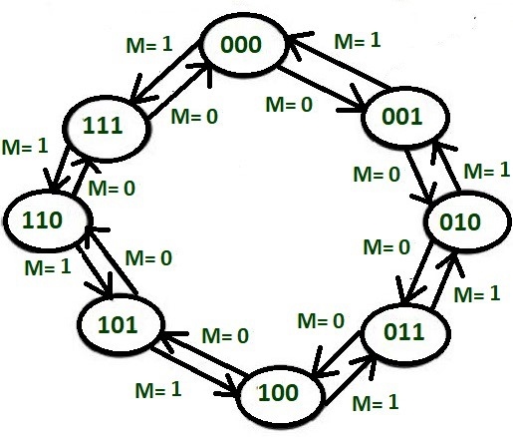

Figure 1: State Diagram of 3-bit up-down ripple counter

c)

module up_down_counter (

    input clk,

    input reset,

    input up_down,

    output reg [2:0] count

);

always @(posedge clk ) begin

    if (reset==1) begin

        count <= 3'b000;

    end else begin

        if (up_down==1) begin

            count <= count + 1;

        end else begin

            count <= count - 1;

        end

    end

end

endmodule

d)

module up_down_counter_tb;

reg clk;

reg reset;

reg up_down;

wire [2:0] count;

up_down_counter uut (

    .clk(clk),

    .reset(reset),

    .up_down(up_down),

    .count(count)

);

always #5 clk = !clk;

initial begin

    $dumpfile("up_down_counter.vcd");

    $dumpvars(0, up_down_counter_tb);

    clk = 0;

    reset = 1;

    up_down = 1;

    #10 ;

    reset =0;

    up_down = 1;

    #100;

     up_down = 0;

    #100;

    $stop;

end

endmodule

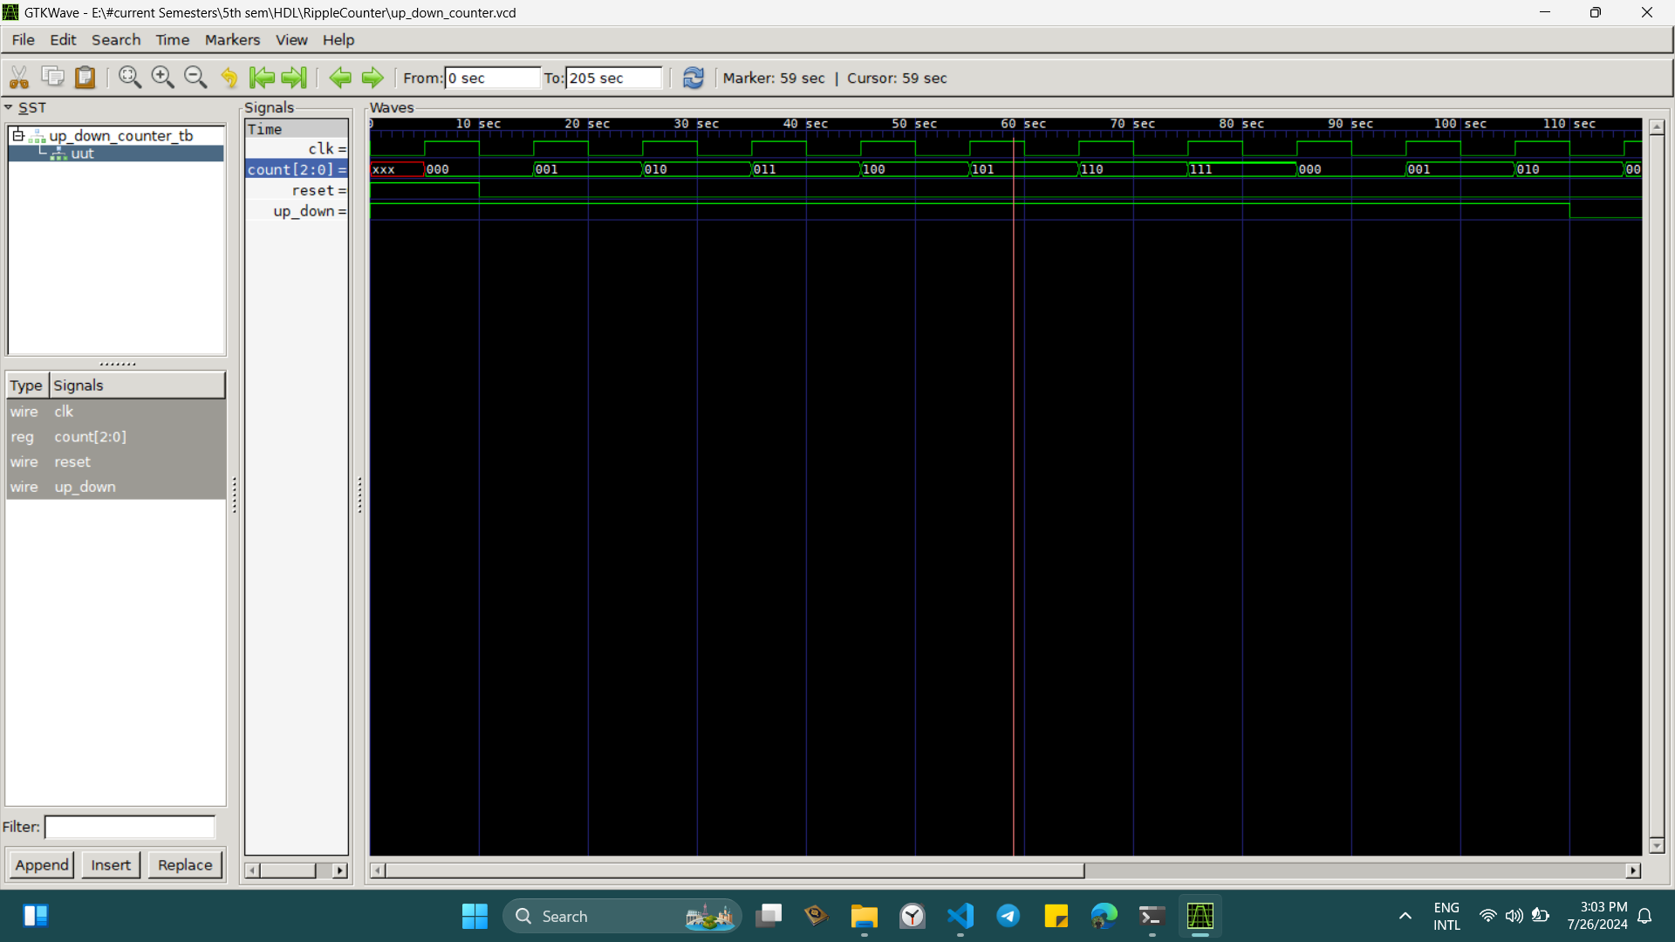

Figure 2 : Output for the test bench code

Q2.

a)

module mux4to1(

input wire [3:0] data_in, // 4-bit data input

input wire [1:0] sel, // 2-bit select input

output wire out // 1-bit output

);

assign out = (sel == 2'b00) ? data_in[0] :

(sel == 2'b01) ? data_in[1] :

(sel == 2'b02) ? data_in[2] :

data_in[3];

endmodule

b)

module mux8to1(

input wire [7:0] data_in,

input wire [2:0] sel,

output wire out

);

wire out1, out2;

mux4to1 mux1 (

.data_in(data_in[3:0]),

.sel(sel[1:0]),

.out(out1)

);

mux4to1 mux2 (

.data_in(data_in[7:4]),

.sel(sel[1:0]),

.out(out2)

);

assign out = (sel[2] == 1'b0) ? out1 : out2;

endmodule

c)

module tb_mux8to1;

reg [7:0] data_in;

reg [2:0] sel;

wire out;

mux8to1 uut (

.data_in(data_in),

.sel(sel),

.out(out)

);

initial begin

$dumpfile("mux8to1.vcd"); // Create a dump file

$dumpvars(0, tb_mux8to1); // Dump all variables in tb_mux8to1

data_in = 8'b00000000;

sel = 3'b000;

#10 data_in = 8'b10101010; sel = 3'b000; // Expected output: 0

#10 data_in = 8'b10101010; sel = 3'b001; // Expected output: 1

#10 data_in = 8'b10101010; sel = 3'b010; // Expected output: 0

#10 data_in = 8'b10101010; sel = 3'b011; // Expected output: 1

#10 data_in = 8'b10101010; sel = 3'b100; // Expected output: 1

#10 data_in = 8'b10101010; sel = 3'b101; // Expected output: 0

#10 data_in = 8'b10101010; sel = 3'b110; // Expected output: 1

#10 data_in = 8'b10101010; sel = 3'b111; // Expected output: 0

#10 $finish;

end

initial begin

$monitor("Time = %0t | data_in = %b | sel = %b | out = %b", $time, data_in, sel, out);

end

endmodule

d)

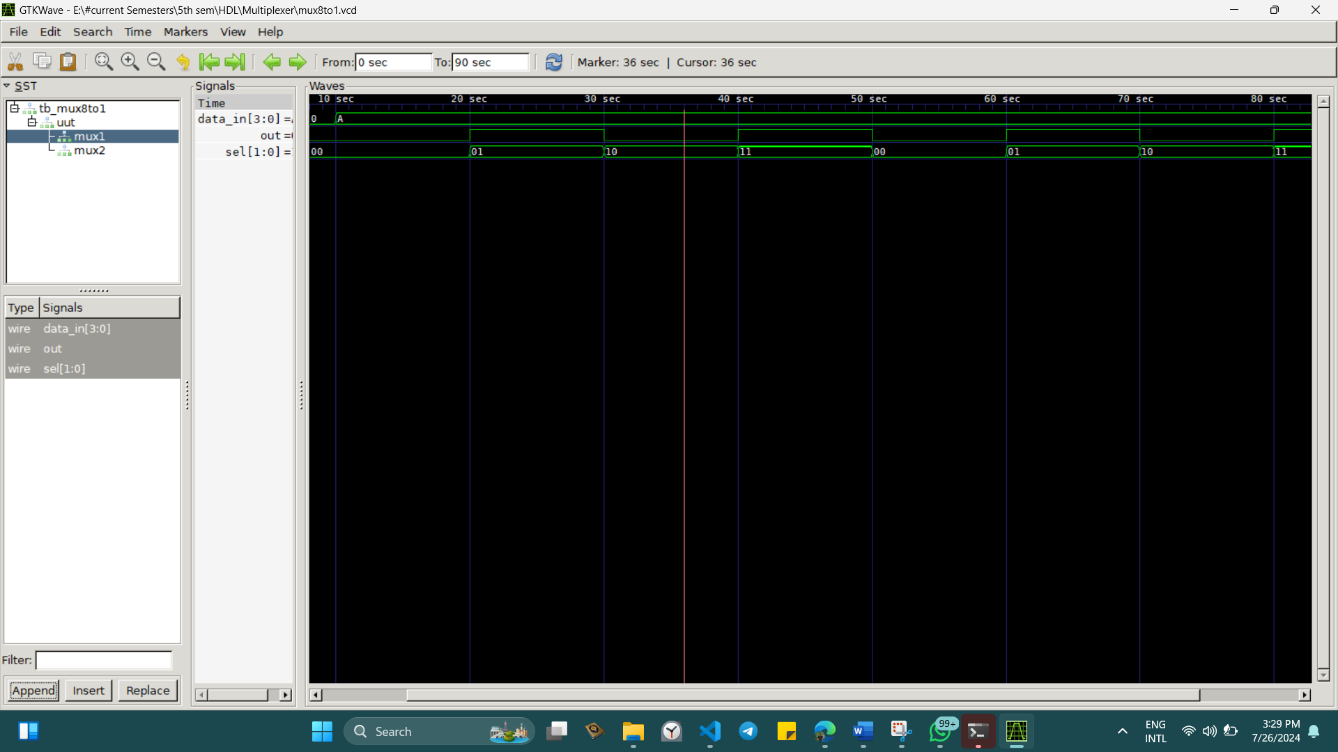

Figure 3 : for 8 to 1 multiplexer